LAB ACTION PLAN FOR WEEK 11

Jenkins-CI/CD
- CI-Continous Integration using Webhooks .
- Sending E-mail Notification on Build Failure or success
- Draw the Usecase ,class,sequence and component diagram for your SDC project of III-I
- Upload the screenshots for the tasks
Lab

Setting Up Jenkins CI------using GitHub Webhook with Jenkins

Step 1: Configure Webhook in GitHub
- Go to your GitHub repository.
- Navigate to Settings → Webhooks.
- Click “Add webhook”.
- In the Payload URL field:
  - Enter the Jenkins webhook URL in the format:
http://<jenkins-server-url>/github-webhook/
Note: If Jenkins is running on localhost, GitHub cannot access it directly.
Use ngrok to expose your local Jenkins to the internet:

  - ngrok.exe http <Jenkins local host:8080>
    - Use the generated ngrok URL, e.g.:
    - http://abc123.ngrok.io/github-webhook/
- Set Content type to:
application/json
- Under “Which events would you like to trigger this webhook?”, select:
  - Just the push event
- Click “Add webhook” to save.
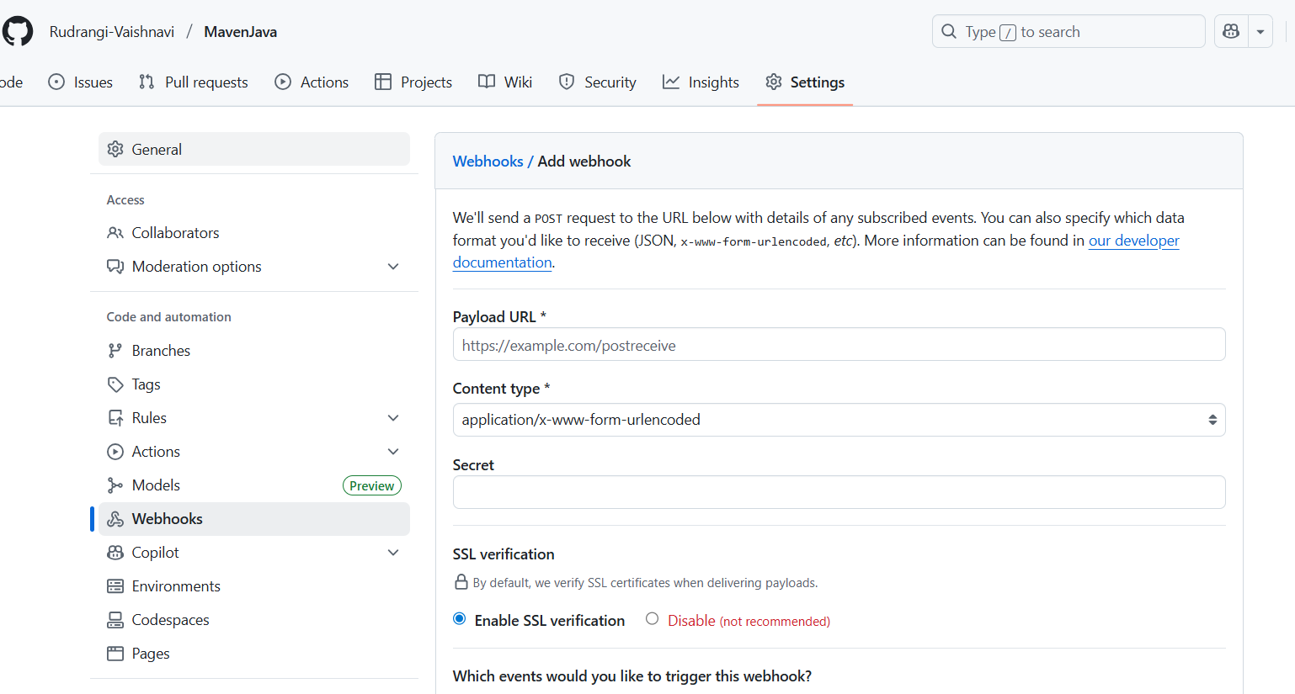

Step 2: Configure Jenkins to Accept GitHub Webhooks
- Open Jenkins Dashboard.
- Select the job (freestyle or pipeline) you’ve already created.
- Click Configure.
- Scroll down to the Build Triggers section.
- Check the box: ✅GitHub hook trigger for GITScm polling
- Click Save.
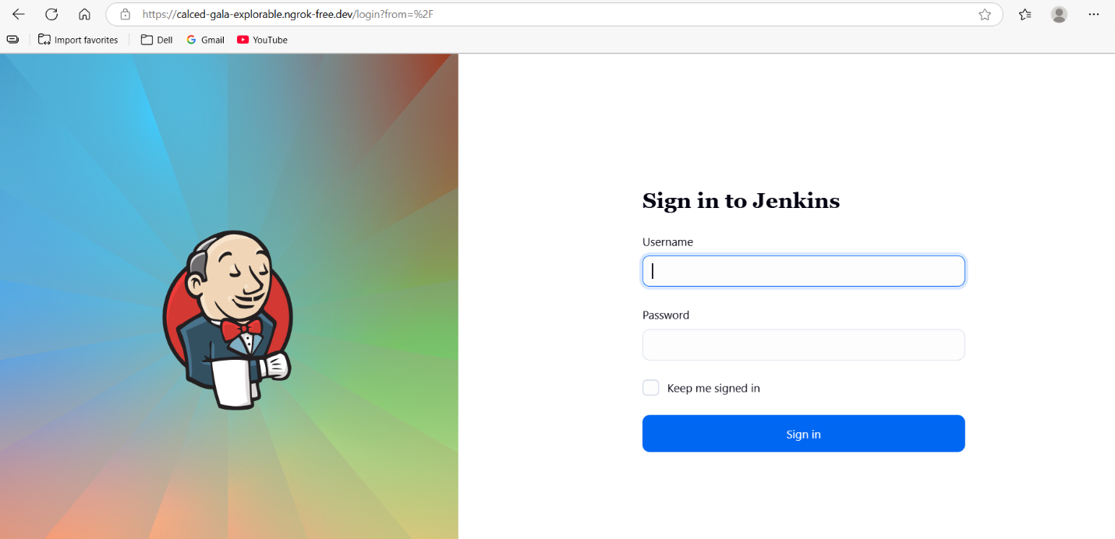
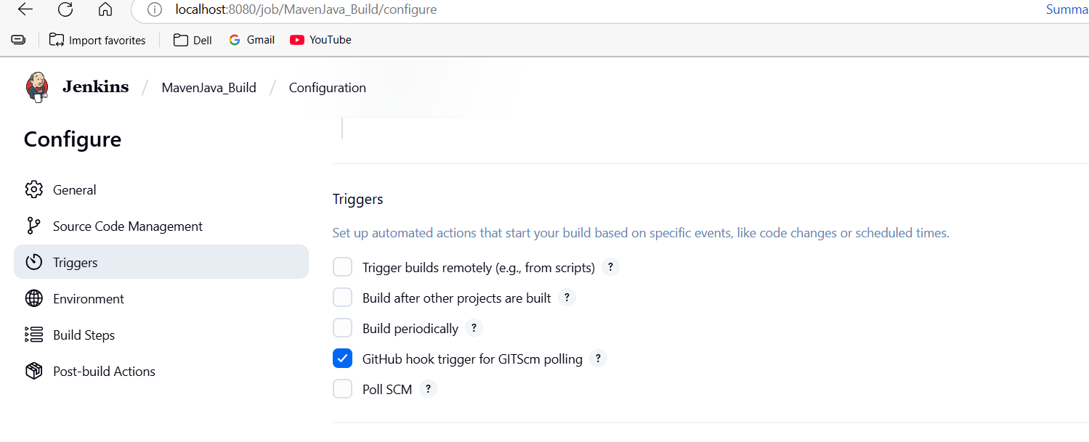

Step 3: Test the Setup
- Make any code update in your local repo and push it to GitHub.
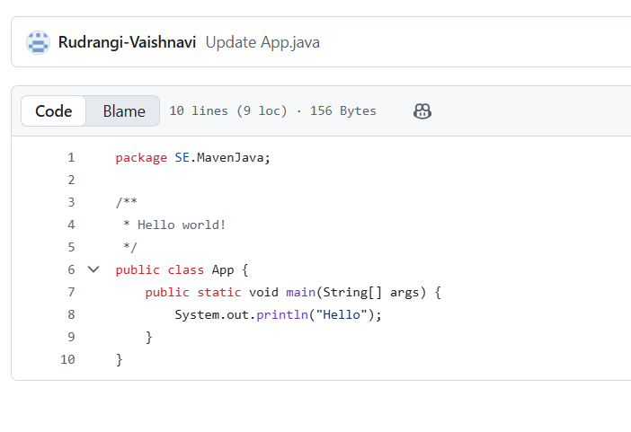
- Once pushed, GitHub will trigger the webhook.
- Jenkins will automatically detect the change and start the build pipeline.
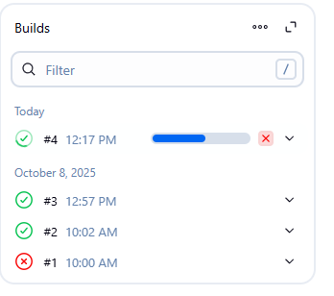

outcome
- You’ve successfully connected GitHub and Jenkins using webhooks.
- Every time you push code to GitHub, Jenkins will automatically start building your project without manual intervention.

Set-uping the ngrok

How to Install and Use ngrok

Step 1. Download ngrok
https://ngrok.com/download
Download and extract it for your OS (Windows, macOS, or Linux).
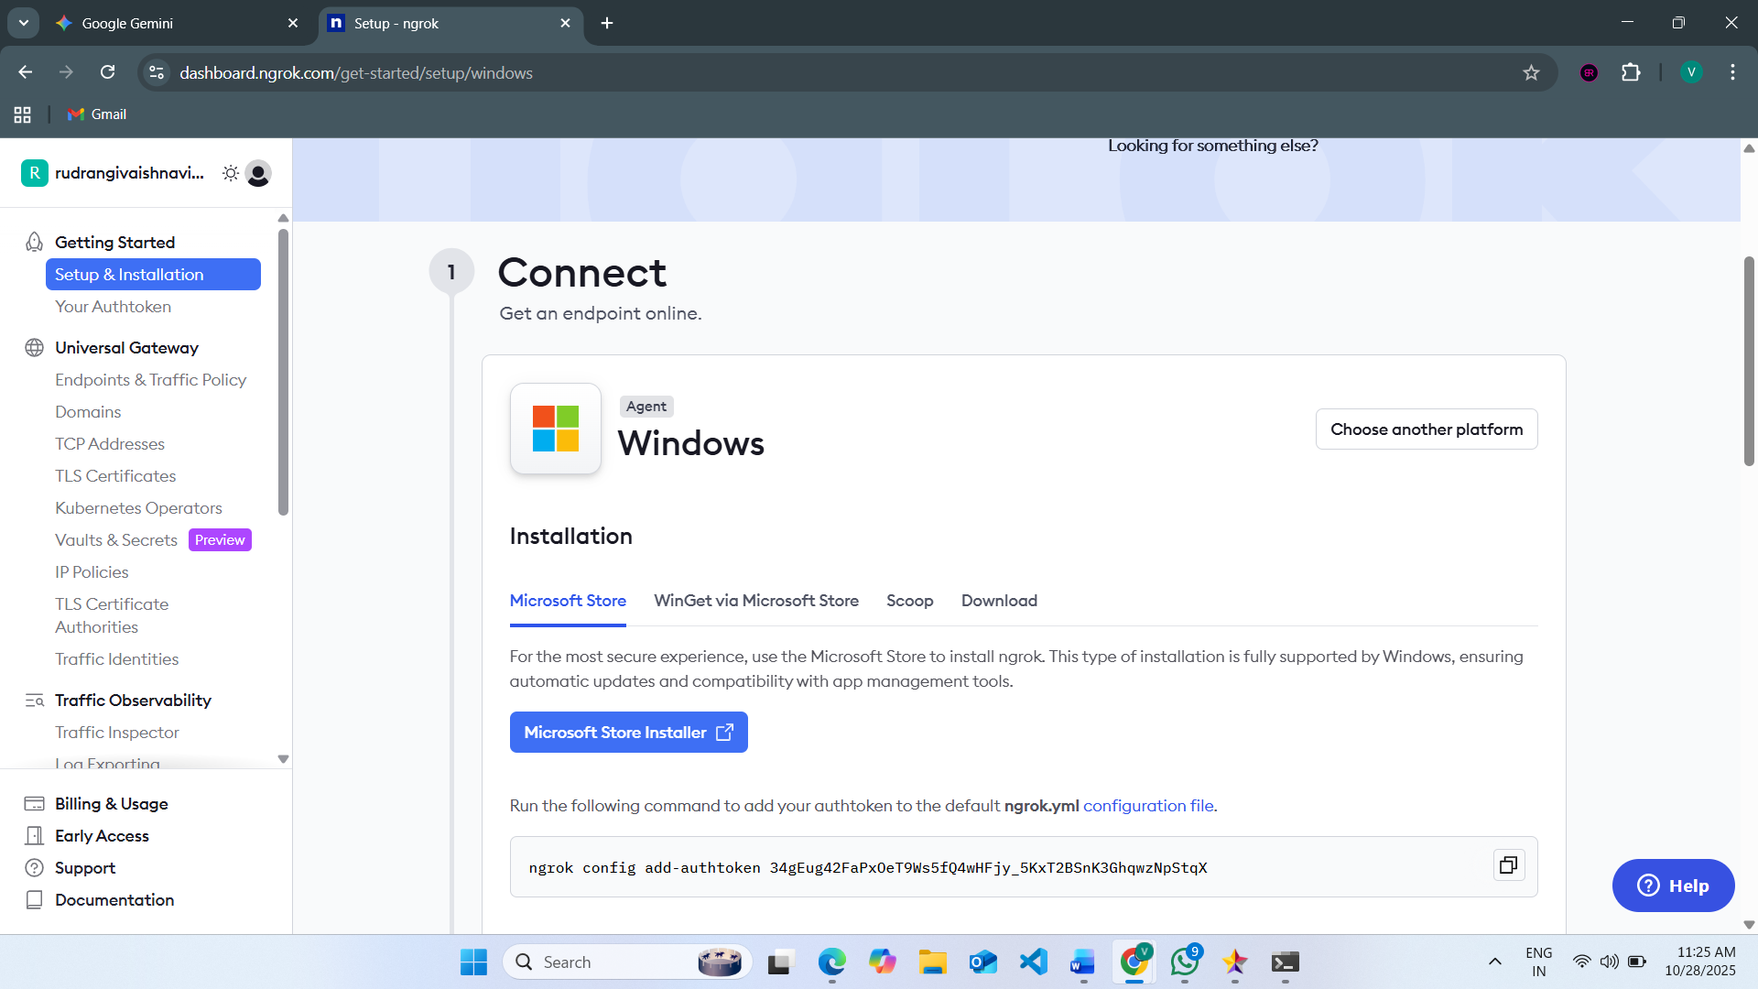

Step 2. Connect Your ngrok Account (optional but useful)
After you sign up (free), ngrok gives you an auth token.
CREATE AUTHENTICATOR [https://dashboard.ngrok.com/get-started/your-authtoken]
Run this command (replace <your_token> with yours):
ngrok config add-authtoken <your_token>
This ensures stable sessions and more control.
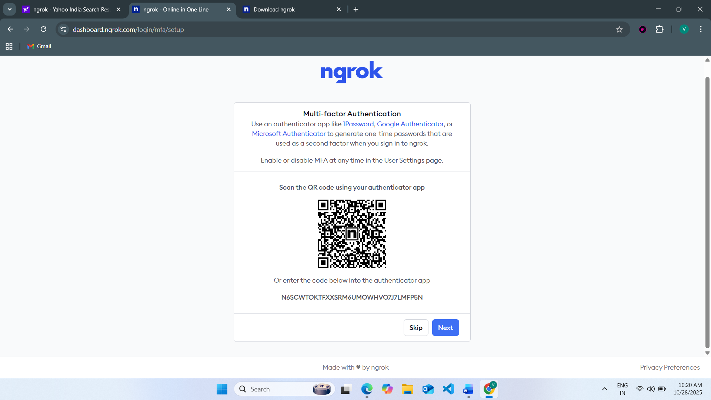

Step 3. Start a Tunnel for Jenkins

Assuming Jenkins runs locally on port 8085:
ngrok http 8085
You’ll see output like:

Session Status online
Forwarding https://1234abcd.ngrok.io -> http://localhost:8080
Copy the HTTPS URL (https://1234abcd.ngrok.io) — this is your public Jenkins URL for webhooks.
Step 4. Use it in GitHub Webhook

In your GitHub repo → Settings → Webhooks:
- Payload URL: [paste the url generated by ngrok]

https://1234abcd.ngrok.io/github-webhook/ [please include this – remaining all default]
Now, whenever you push code, GitHub sends an event to that URL, which ngrok forwards to your local Jenkins.
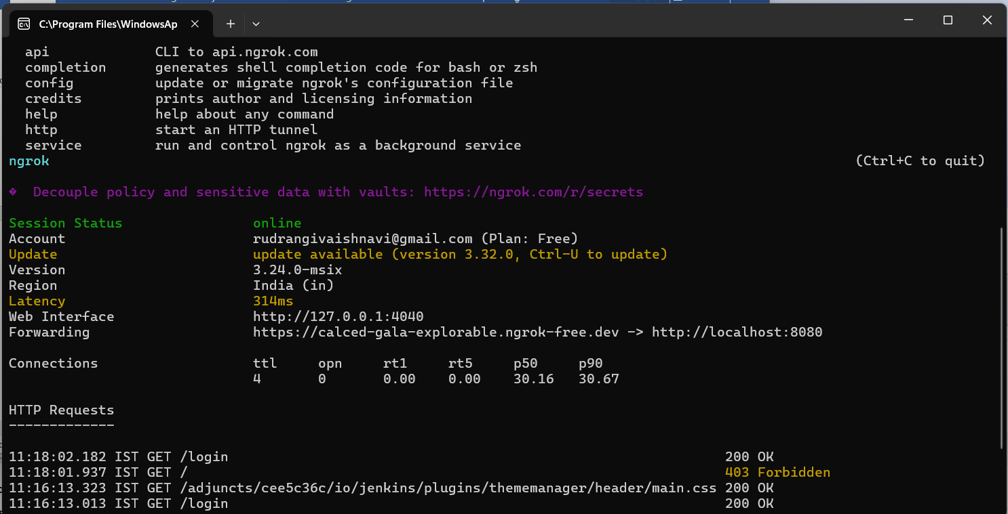

------------------------------------------------------------------------------------------------------------------------------------------
Setting Up Jenkins Email Notification Setup (Using Gmail with App Password)
Creation of app password
1. Gmail: Enable App Password (for 2-Step Verification)
i. Go to: https://myaccount.google.com
ii. Enable 2-Step Verification
- Navigate to:
  - Security → 2-Step Verification
  - Turn it ON
  - Complete the OTP verification process (via phone/email)
iii. Generate App Password for Jenkins
- Go to:
  - Security → App passwords
- Select:
  - App: Other (Custom name)
  - Name: Jenkins-Demo
- Click Generate
- Copy the 16-digit app password
  - Save it in a secure location (e.g., Notepad)
2. Jenkins Plugin Installation
i. Open Jenkins Dashboard
ii. Navigate to:
- Manage Jenkins → Manage Plugins
iii. Install Plugin:
- Search for and install:
  - Email Extension Plugin

3. Configure Jenkins Global Email Settings
i. Go to:
- Manage Jenkins → Configure System

A. E-mail Notification Section
Field | Value
SMTP Server | smtp.gmail.com
Use SMTP Auth | ✅ Enabled
User Name | Your Gmail ID (e.g.,bhargavikumbham@gmail.com)
Password | Paste the 16-digit App Password
Use SSL | ✅ Enabled
SMTP Port | 465
Reply-To Address | Your Gmail ID (same as above)
➤ Test Configuration
- Click: Test configuration by sending test e-mail
- Provide a valid email address to receive a test mail
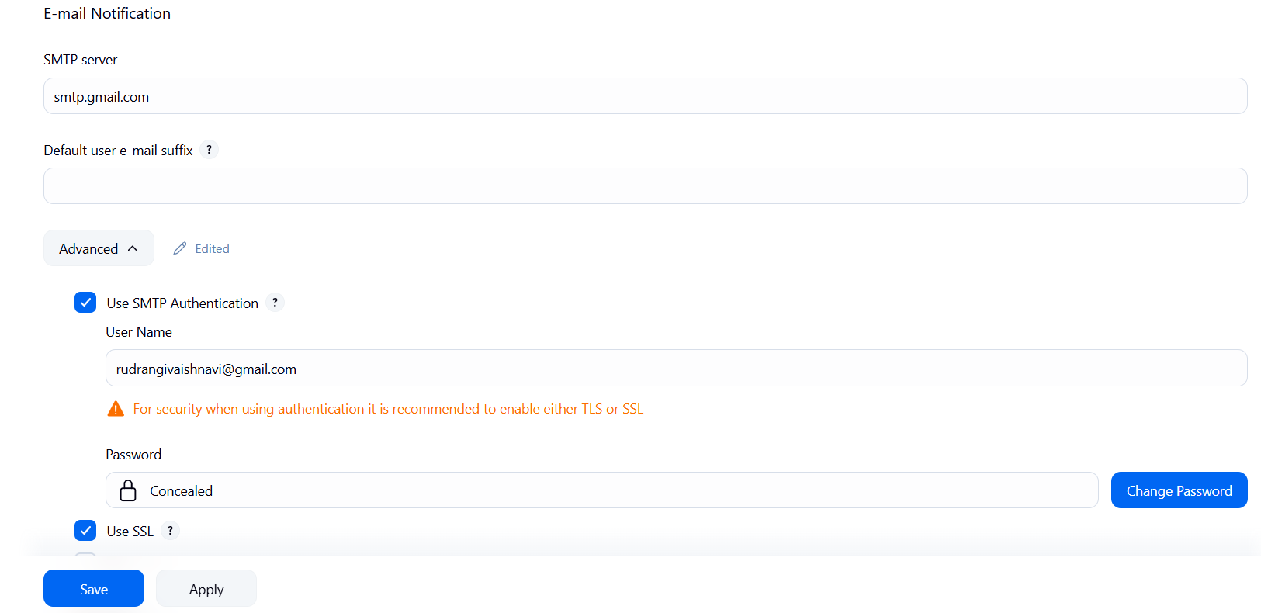
- ✅ Should receive email from Jenkins
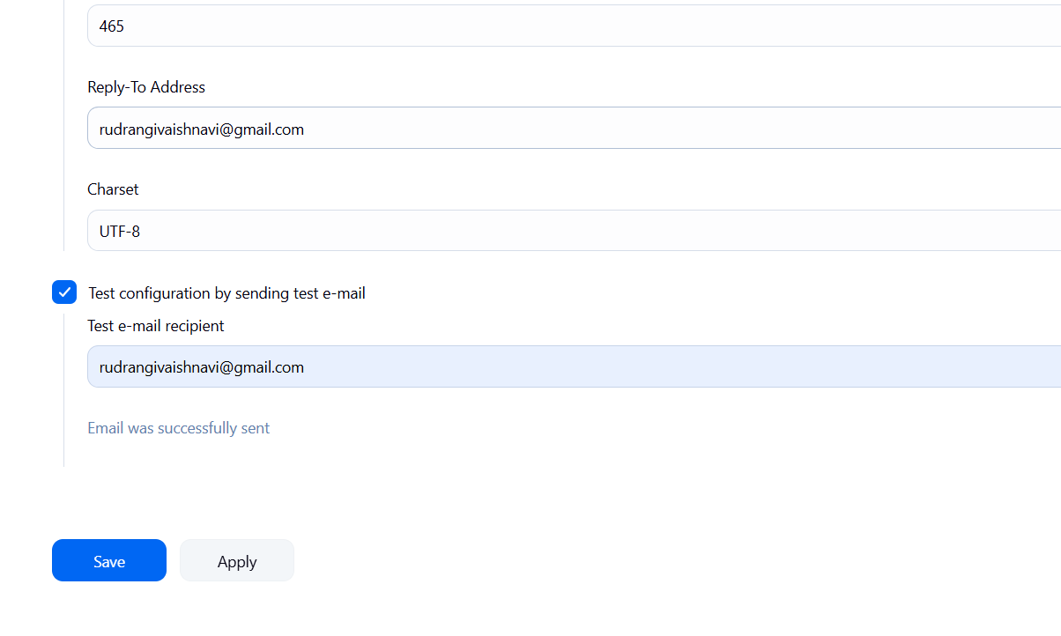
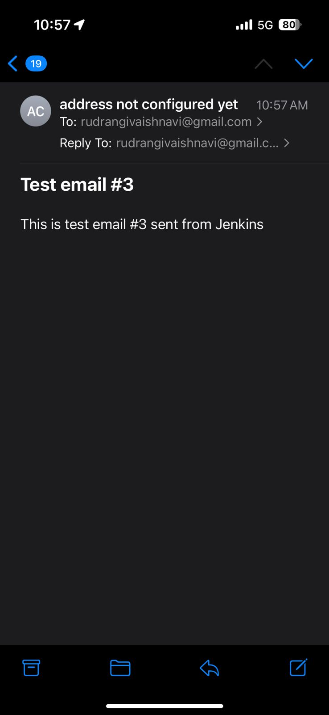

B. Extended E-mail Notification Section
Field | Value
SMTP Server | smtp.gmail.com
SMTP Port | 465
Use SSL | ✅ Enabled
Credentials | Add Gmail ID and App Password as Jenkins credentials
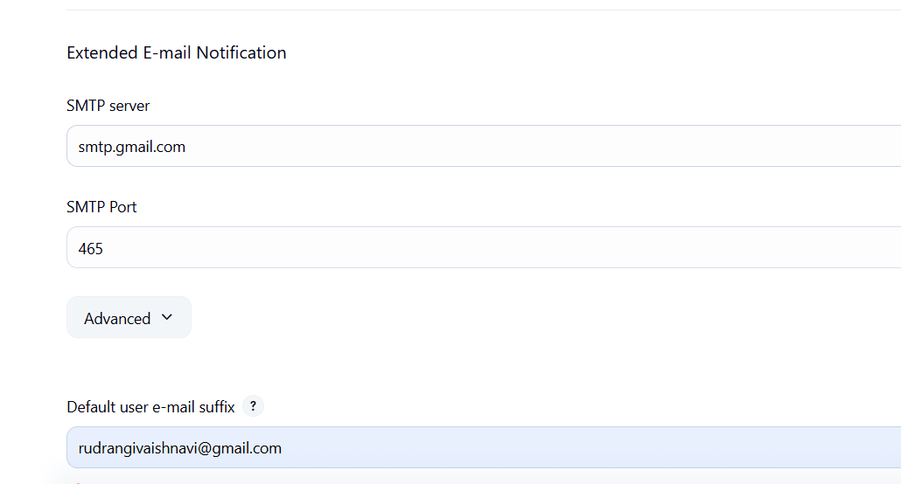
Default Content Type | text/html or leave default
Default Recipients | Leave empty or provide default emails
Triggers | Select as per needs (e.g., Failure)

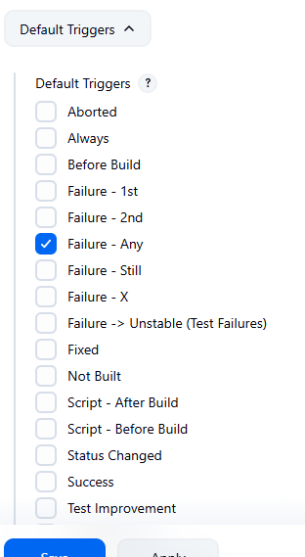

4. Configure Email Notifications for a Jenkins Job
i. Go to:
- Jenkins → Select a Job → Configure

ii. In the Post-build Actions section:
- Click: Add post-build action → Editable Email Notification
A. Fill in the fields:
Field | Value
Project Recipient List | Add recipient email addresses (comma-separated)
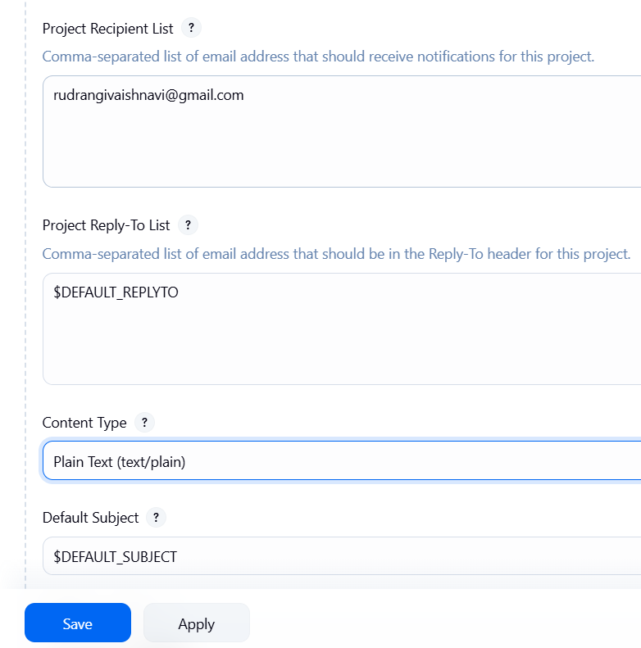
Content Type | Default (text/plain) or text/html
Triggers | Select events (e.g., Failure, Success, etc.)
Attachments | (Optional) Add logs, reports, etc.

iii. Click Save

Now your Jenkins job is set up to send email notifications based on the build status!

Takeaway :
Students learned how to integrate Jenkins with GitHub using webhooks to automate build triggers and configure email notifications to monitor build success or failure effectively.
Viva Questions
1. What is Continuous Integration (CI)?
CI means frequently merging code and automatically testing it to find errors early.

2. What is Continuous Deployment or Continuous Delivery (CD)?
CD automates building, testing, and deploying code to production after each change.

3. What is the role of Jenkins in a CI/CD pipeline?
Jenkins automates the build, test, and deployment process.
4. What is a webhook in GitHub?
A webhook sends real-time notifications to external tools when events (like pushes) occur.

5. Why are webhooks used in Jenkins integration?
To automatically trigger Jenkins jobs when code is pushed to GitHub.

6. What are the different types of build triggers available in Jenkins?
Manual, Periodic, Poll SCM, GitHub Webhook, and Trigger by other jobs.

7. What is the difference between polling and webhook triggers?
Polling checks for updates at intervals; webhook triggers instantly on change.

8. What is ngrok and why is it used in Jenkins–GitHub integration?
Ngrok creates a public URL for local Jenkins, allowing GitHub to connect via webhook.

9. How does ngrok help in setting up webhooks for Jenkins running on a local machine?
It tunnels GitHub’s webhook requests to the local Jenkins server.

10. Why do we configure email notifications in Jenkins and how are they useful?
To alert developers about build results—success or failure—for quick issue tracking.

